Home
Management
Binder

Passwords

WEBSITE | USERNAME | PASSWORD | NOTES

Important Contacts

Name |  | Email |  | Notes:
Title |  | Phone
Name |  | Email |  | Notes:
Title |  | Phone
Name |  | Email |  | Notes:
Title |  | Phone
Name |  | Email |  | Notes:
Title |  | Phone
Name |  | Email |  | Notes:
Title |  | Phone
Name |  | Email |  | Notes:
Title |  | Phone
Name |  | Email |  | Notes:
Title |  | Phone
Name |  | Email |  | Notes:
Title |  | Phone
Name |  | Email |  | Notes:
Title |  | Phone
Name |  | Email |  | Notes:
Title |  | Phone
Name |  | Email |  | Notes:
Title |  | Phone
Name |  | Email |  | Notes:
Title |  | Phone
Name |  | Email |  | Notes:
Title |  | Phone
Name |  | Email |  | Notes:
Title |  | Phone
Name |  | Email |  | Notes:
Title |  | Phone
Name |  | Email |  | Notes:
Title |  | Phone
Name |  | Email |  | Notes:
Title |  | Phone

City Contacts

CITY OFFICES
Building and Safety
Main City Line
City Clerk
City Manager
Community Development
Finance
Public Works
Recreation and Parks
Electronics & Bulk Item Pick up
EMERGENCY
Local Sheriff's Station
Local Fire Station
ANIMAL & PEST CONTROL
Animal Control
Bee Removal
Chamber of Commerce
Vector Control

CITY HALL STAFF
Name | Title | Email | Phone

Trash Collection

Your Trash Collection Day: THURSDAY
Holidays on Saturdays DO NOT delay waste removal services.
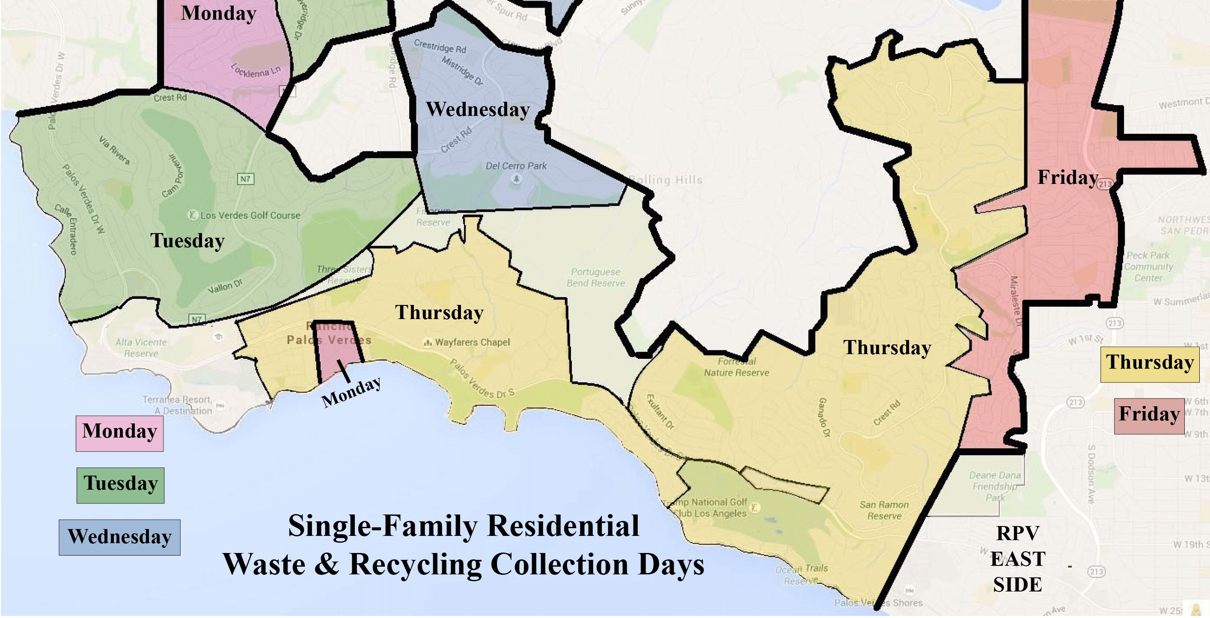
Local Eats

LOCATION
Name | Phone
LOCATION
Name | Phone

Local Businesses

GROCERY STORES
Name | Location / Address | Hours of Operation

Local Medical Offices
Name | Location / Address | Phone

OTHER ESSENTIAL BUSINESSES
Name | Location | Hours of Operation
Post Office
The UPS Store
Fedex
Goodwill
Location Auto Shop

